Portfolio for Charles R. Grosvenor Jr.

399 Rochdale St.
Auburn, MA 01501

Home: 508.832.3527 chuck@worcestermass.com

Introduction
I am a web developer with experience in both software development and visual design. This portfolio demonstrates some of the most recent visual design work I’ve done.

Website - CVS Health – CVS.com – 2016
This is a responsive desktop/mobile design for a new header on all pages of CVS. Not all pages on the site use a responsive layout (some are served through a 3rd party provider for mobile devices, so some pages have just a desktop layout). The following examples show a page as it is reloaded at each resolution. This redesign was to solve 508 compliance issues as well as new corporate branding.

Desktop wide (>960px)
Here is the largest layout.
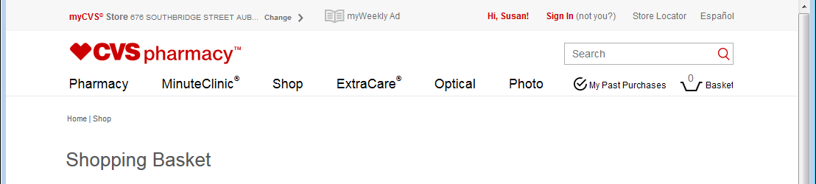

Desktop narrow (>768px and & 960px)
When a user visits a page in this size range, the angular component loads with a smaller amount of characters in the “myCVS store” section and the word spacing is reduced on the main navigation links (Pharmacy, MinuteClinic, etc).
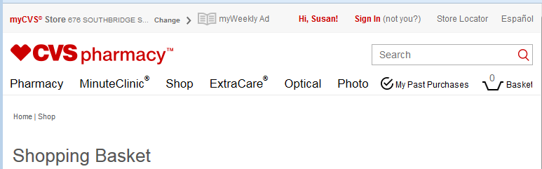

Mobile & Tablet (320px -> 768px)
At this size, the desktop header is replaced with a single navigation bar and a search box. The navigation bar scrolls off the page when the user scrolls down, but will reappear when a user scrolls upwards.
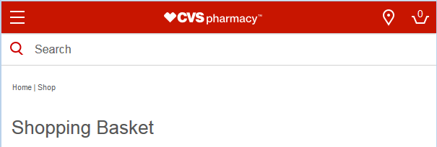

Mobile Hamburger Menu (<769px)
Depending on the login status of the user, different information is displayed to the user in the top navigation section (pictured below is a signed out, but remembered user). On pressing the hamburger menu icon, the page content slides sideways with a CSS transition.
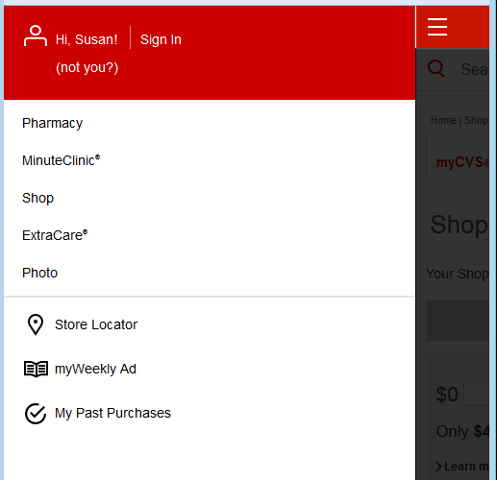

Email - CVS Health – CVS.com – 2015
This is a responsive desktop/mobile design for an email to be sent to users who reserve an opening at a Minute Clinic at CVS. Responsive in email is more challenging due to a lack of standards, lack of Javascript, and ancient HTML standards used in MS Outlook. A combination of HTML 4 tables and CSS enables an email that is responsive.

Desktop (>768px)
This was targeted at MS Outlook, but also displays fine in Gmail and Apple iCloud Mail Desktop.

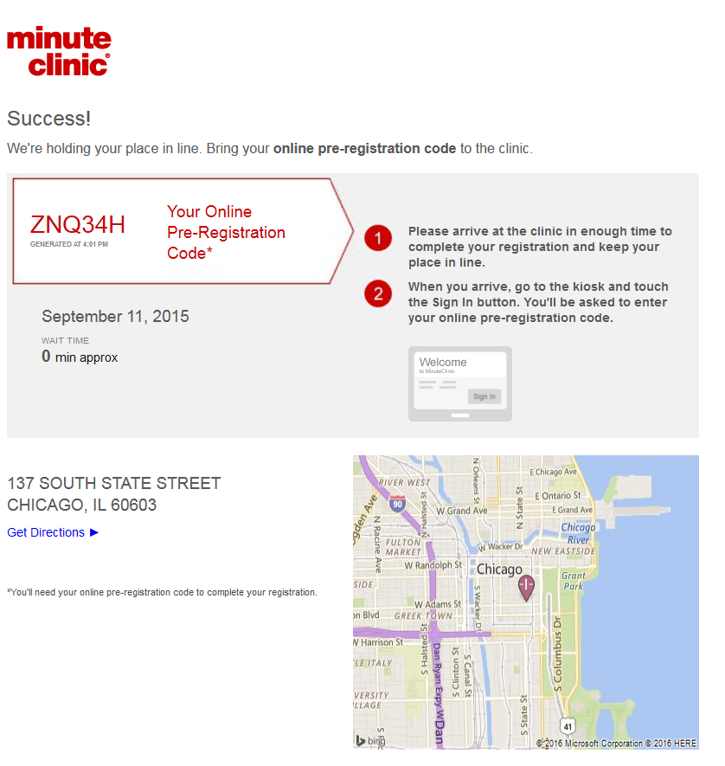

Mobile & Tablet (320px -> 768px)
If a user opened the email in Gmail or Apple iCloud Mail on a mobile device they would see this view.

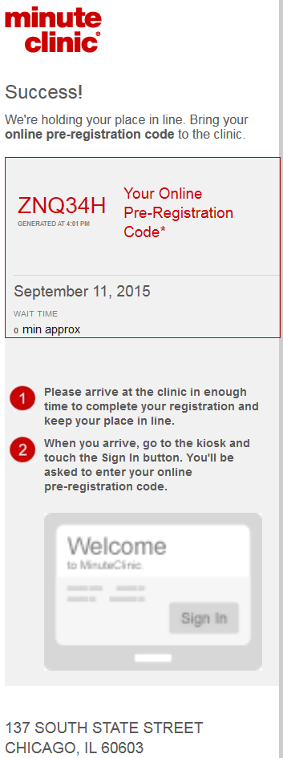

Website - Cantor-Fitzgerald - Cantor Exchange Flex Trading App – 2013
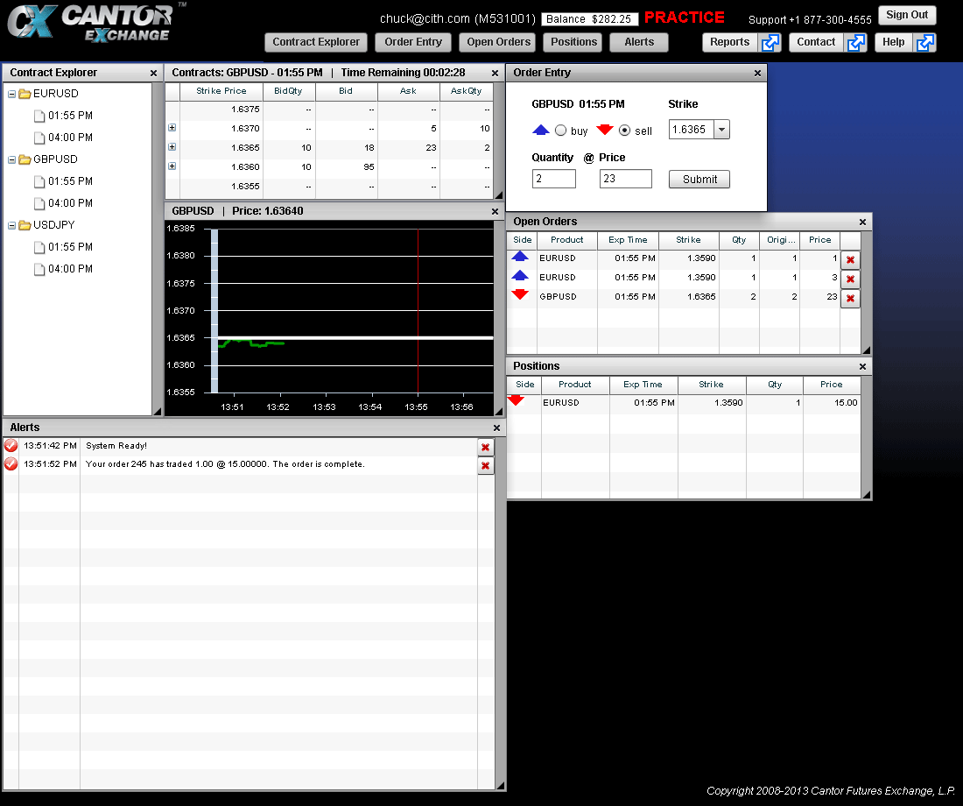
This is a real-time event-driven trading system implemented in FLEX. The “Contract Explorer” tree view on the left side controls which contract the user currently sees. The user can then click on a contract in the contracts window to fill in the order entry window or manually select the options they want for placing an order. New orders appear in the open orders window.

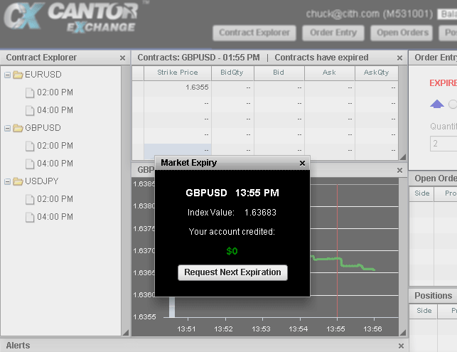
When a contract reaches its expiration time, a modal window would alert the user of their gain/loss for the contract and give them the option to select the next available contract in that product.

Website - Cantor-Fitzgerald - Cantor Exchange PHP Application – 2013
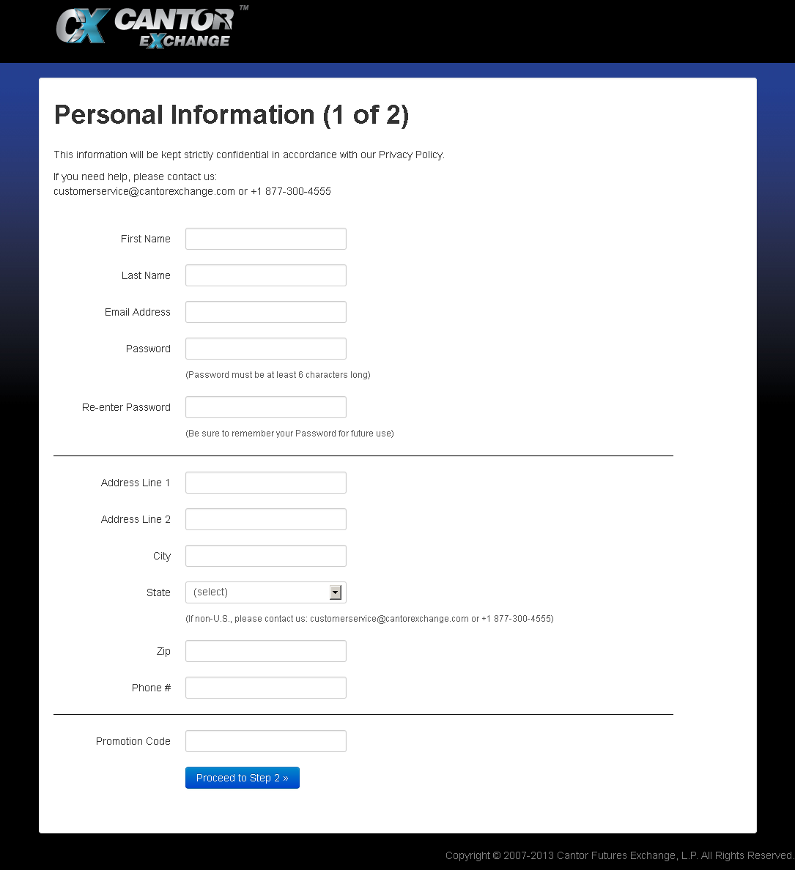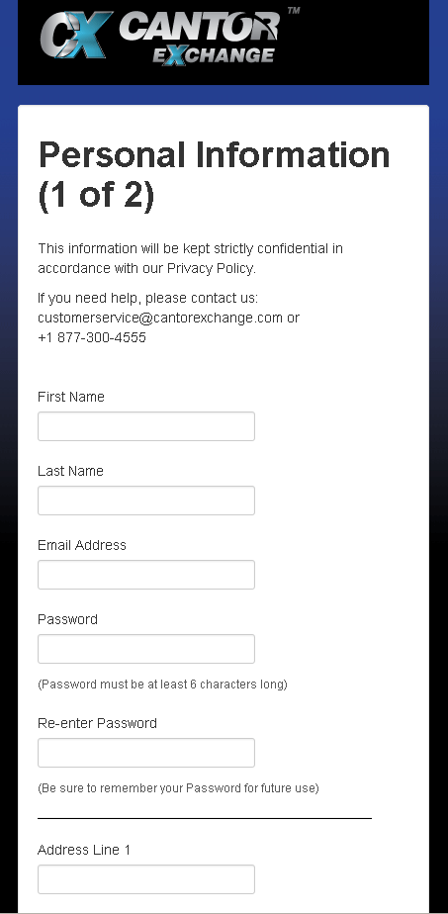
This website was designed for users to apply for a trading account. The left screenshot is of the page in a desktop environment, the right screenshot is how it appears on a mobile phone browser. Bootstrap was used for the grid system to allow the form to collapse to a single column.

Website - Cantor-Fitzgerald - Cantor Exchange PHP Reports Website – 2013
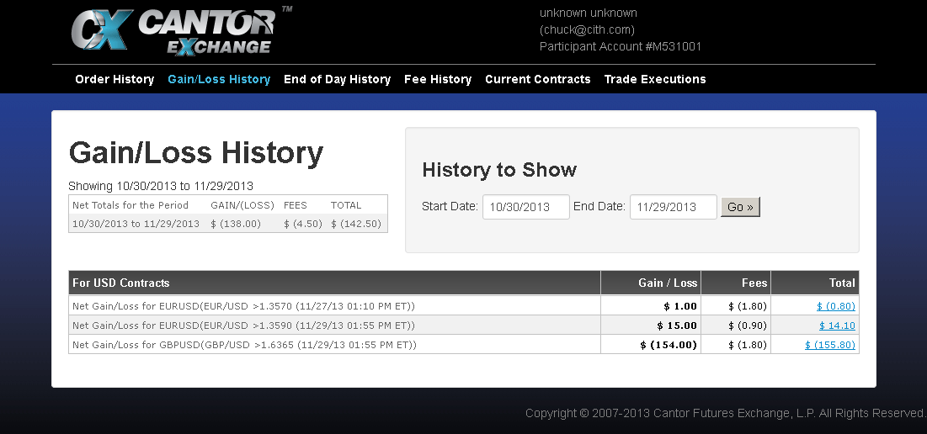A web based report tool for the trading app. It is used both as a standalone website with a logon screen and is also used inside of an iPad and Android app embedded browser.

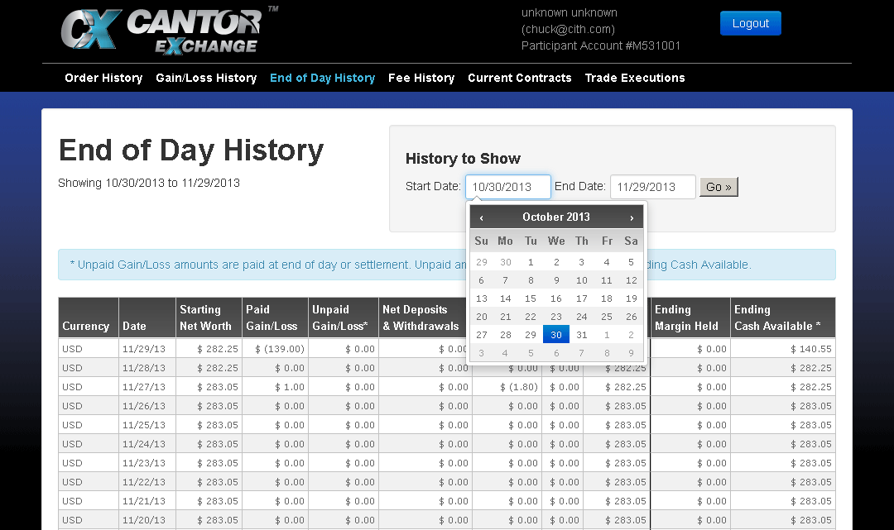A jQuery calendar was implemented for picking dates, a funding form also used jQuery for field validation.

Website - SAIC – ASP .Net Website for Instructional Designers 2012
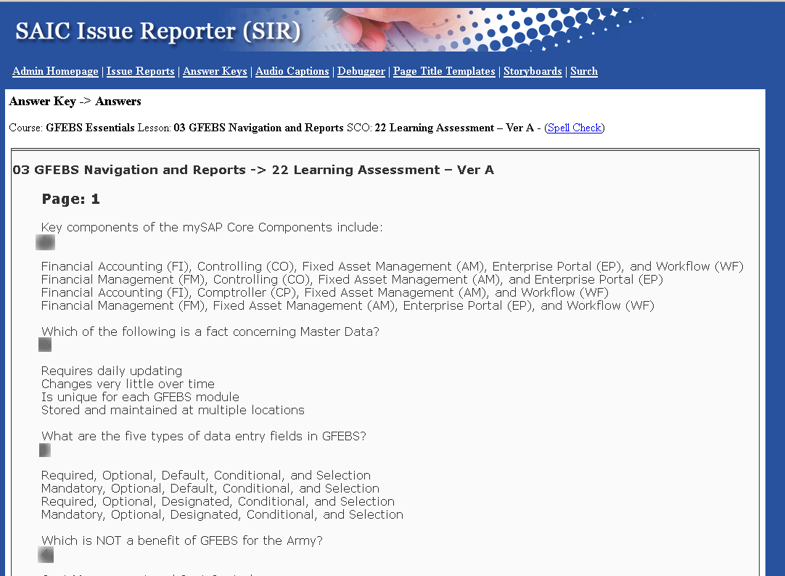
Answer key generated by retrieving all questions from SQL database, (answers have been grayed out for this screenshot since this is a real course).

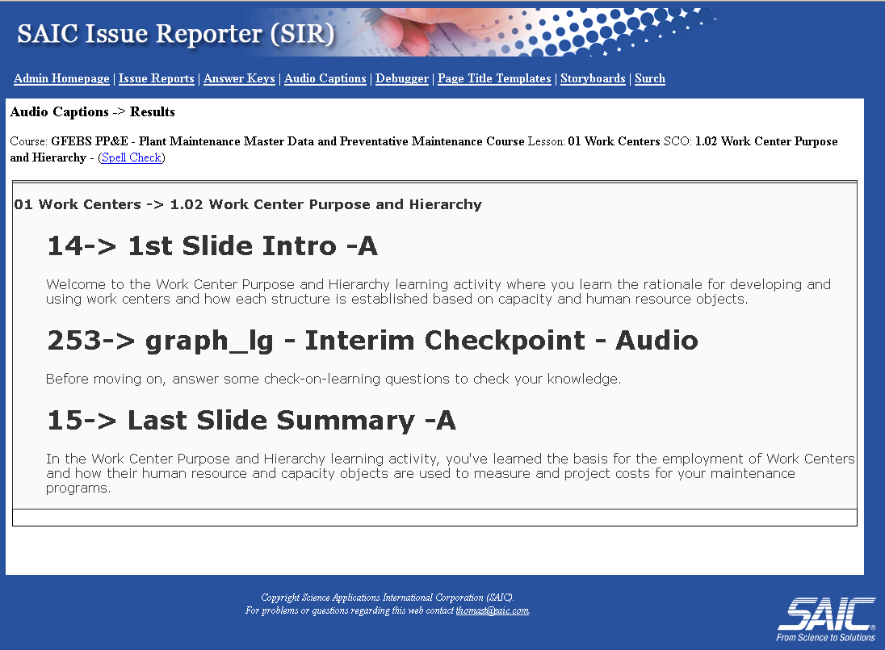
Audio captions, a custom sort of the storyboard pages to present just the frames which had audio captions used on their pages. Spell check was accomplished by using JavaScript to make the frames “editable”. Firefox’s internal spell check would then highlight words it did not recognize.

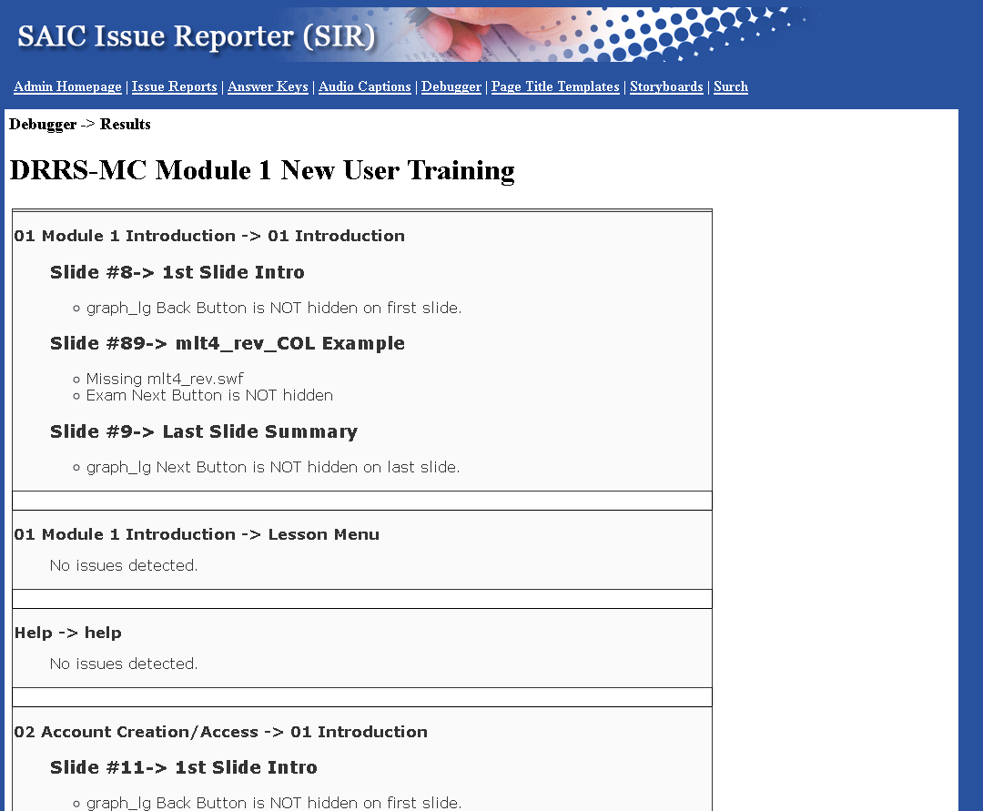
The debugger would look through all the frames of a course to find issues that courseware designers may have missed when filling in templates for their courses.

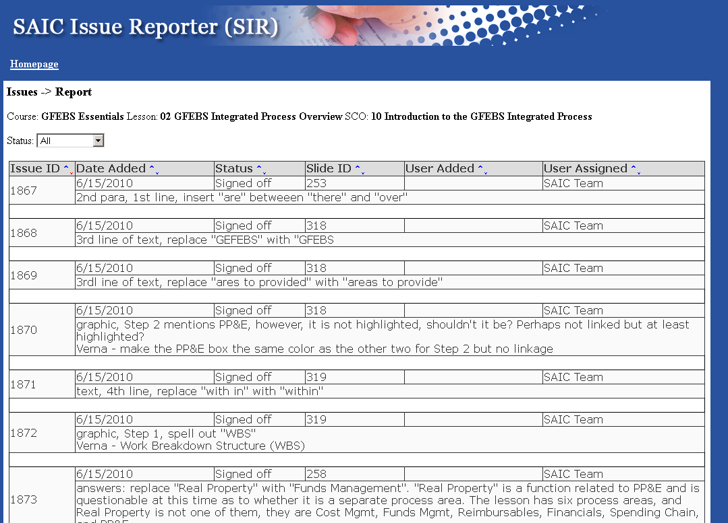
Issues report would take the issues entered by the customer into the courseware designer and present a report that could be printed out and included with delivery of the courseware.

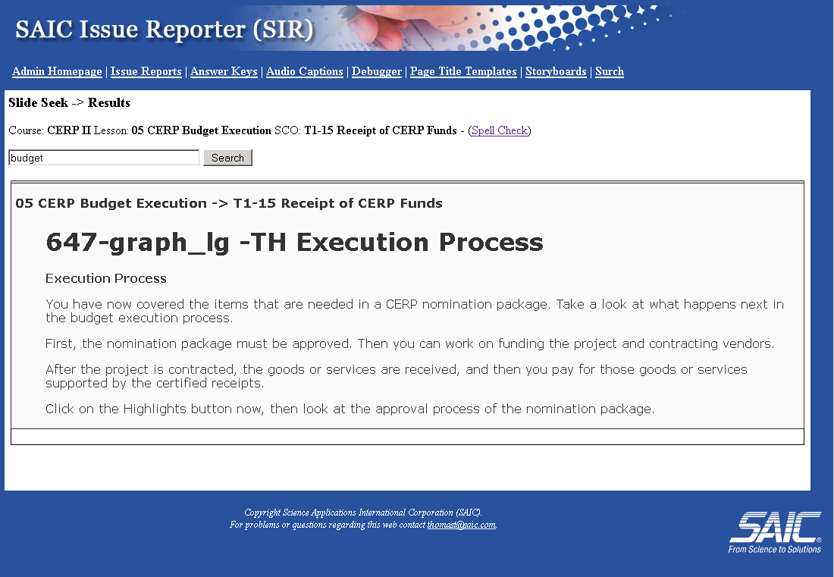
Search function to query the database for various frames of a course which match the string entered by the user. User can drill into a specific lesson or search an entire course.

Storyboard users can select a particular lesson or the entire course and display all the various elements of the course. Images were retrieved from the database and SWF movies had a screenshot taken after 15 seconds with an external program to illustrate them. Images are cached so that the user only need retrieve new items as the course is developed.

Website - onExchange – 2003

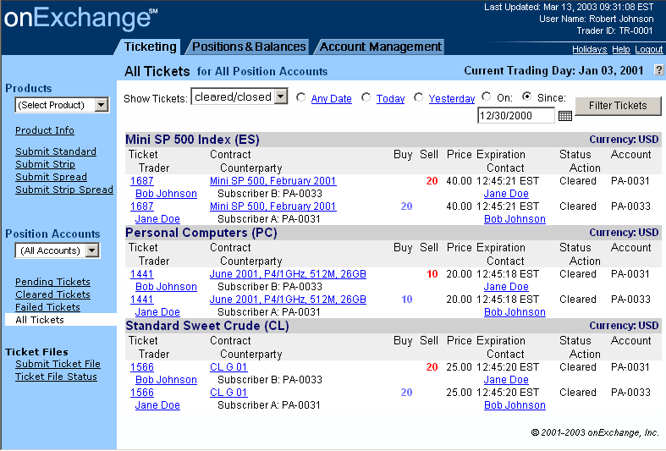
Web trading interface for onExchange. I was asked to use less whitespace here to increase the amount of information displayed. This was done with HTML 4.0 and was backwards compatible to Netscape 4.X and IE 5.

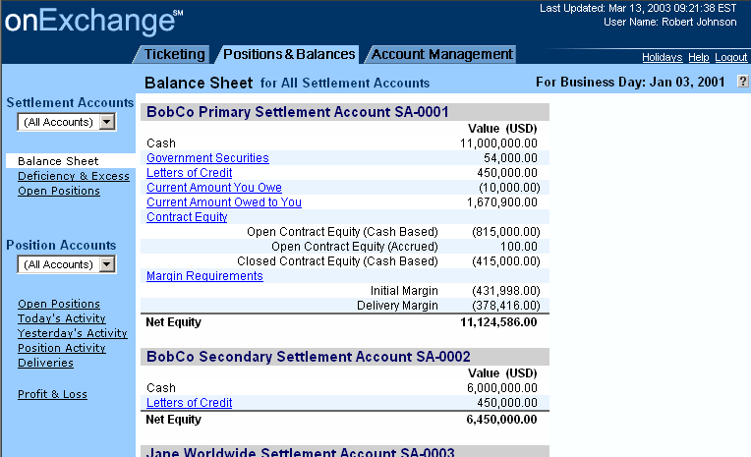
An example of the balance sheet.
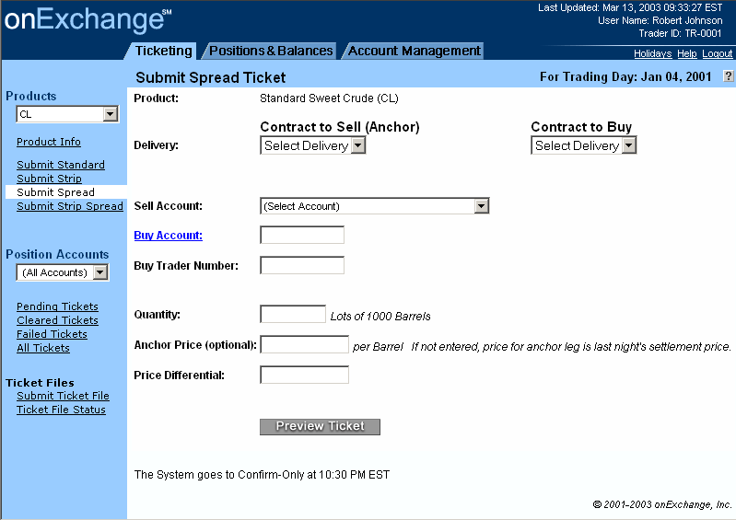
This is an example of an order entry screen. JavaScript was used to ensure fields were filled in and contained proper dollar amounts.

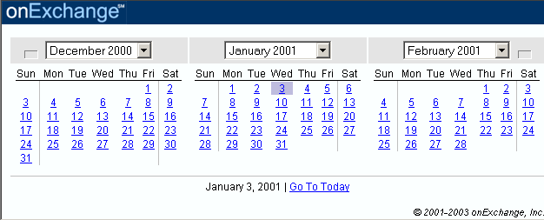
This is an example of the JavaScript pop up calendar used for entering dates on the history pages.

Logo Design

amIright.com - a website specializing in music humor.

amIwrong – a website specializing in pop culture quizzes

OnlyOnFilm.com – a website specializing in screenshots of buildings in movies that no longer exist.

